My SQL Query

Coffee Shop Sales Project

1. convert data column to proper format

UPDATE coffe_shop

SET transaction_date = STR_TO_DATE(transaction_date, '%m/%d/%Y');

alter table coffe_shop

modify column transaction_date date ;

1. Convert time column into proper format

update coffe_shop

set transaction_time = str_to_date(transaction_time, '%H:%i:%s') ;

alter table coffe_shop

modify transaction_time time ;

1. Rename the column transaction_id to id

alter table coffe_shop

change transaction_id id int ;

1. Data type of all column

describe coffe_shop ;

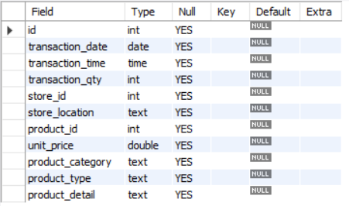

KPI's Requirements

1. Total sales

select concat(round(sum(unit_price * transaction_qty))/1000 , 'K') as total_sales

from coffe

where

month(transaction_date) = 5 ;



1. Calculate Groth by month

select

month(transaction_date) as month ,

round(sum(unit_price * transaction_qty)) as Total_sales ,

round((sum(unit_price * transaction_qty) - lag(sum(unit_price * transaction_qty) , 1)

over(order by month(transaction_date)))

/

lag(sum(unit_price *transaction_qty ) , 1) over(order by month(transaction_date)) * 100,2 )as mom_percentage

from coffe

group by

month(transaction_date)

order by

month(transaction_date) ;

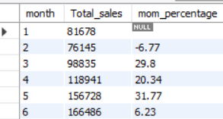

1. Total orders

select count(distinct id) as total_orders

from coffe

where month(transaction_date) = 5 ;



MOM regarding orders

select

month(transaction_date) as Month ,-- frist col for month

round(count(id)) as Total_orders , -- second_col for total orders

(count(id) - lag(count(id) , 1) over(order by month(transaction_date)))

/

lag(count(id) , 1) over(order by month(transaction_date)) * 100 as MOM_percentag

from

coffe

group by

month(transaction_date)

order by

month(transaction_date) ;

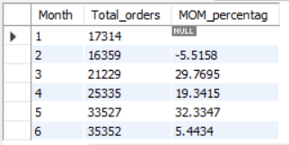

1. Total quantity sold

select sum(transaction_qty) as total_quantit_sold

from coffe

where month(transaction_date) = 5;



1. Calculate groth for quantity sold

select

month(transaction_date) as Month ,

sum(transaction_qty) as total_quantit_sold ,

round( (sum(transaction_qty) - lag(sum(transaction_qty) , 1) over(order by month(transaction_date)))

/

Lag(sum(transaction_qty) , 1) over(order by month(transaction_date)) *100 ,2)as MOM_quantit_sold

from

coffe

group by

Month

order by

Month ;

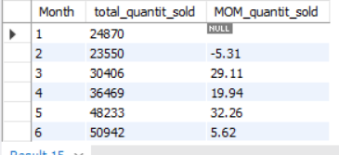

1. Calculate total sales in weekdays and weekend

select

case when dayofweek(transaction_date) in (1,7) then 'Weekend'

else 'Weekdays'

end as day_type ,

concat(round(sum(unit_price *transaction_qty) /1000 , 1),'K') as total_sales

from

coffe

where month(transaction_date) = 5

group by

day_type ;

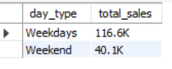

1. Total_sales by store location

select

store_location ,

concat(round(sum(unit_price *transaction_qty) /1000,1) , 'K') as total_sales

from

coffe

where

month(transaction_date) = 5

group by store_location

order by total_sales desc ;

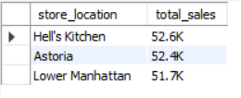

1. average for may

select

round(avg(total_sales)) as Avg_sales

from

(

select sum(unit_price *transaction_qty) as total_sales

from coffe

where month(transaction_date) = 5

group by transaction_date

) as intern_query

;



1. which day is greater than the avg of the specefied month

select day_of_month ,

case

when total_sales > avg_sales then "Above Avg"

when total_sales < avg_sales then "Below Avg"

else 'equal to avg'

end as Sales_status ,

total_sales , avg_sales

from (

select

day(transaction_date) as day_of_month , -- for day number

round(sum(unit_price *transaction_qty)) as total_sales ,

round(avg(sum(unit_price *transaction_qty))over(),1) as avg_sales

from coffe

where

month(transaction_date) = 5

group by

day_of_month ) as internal_table ;

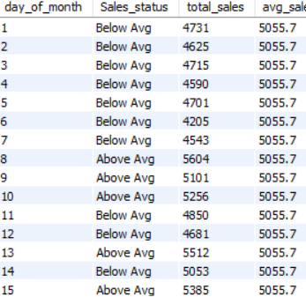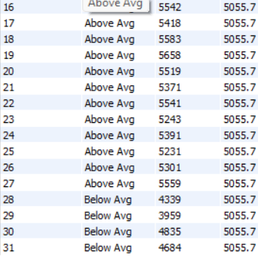

1. sales with respect to product_category

select product_category ,

round(sum(unit_price *transaction_qty)) as total_sales

from

coffe

where

month(transaction_date) = 5

group by

product_category

order by

total_sales ;

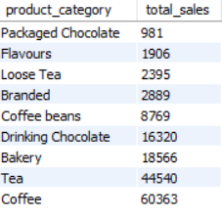

-- sales with respect to product_type top 10

select product_type ,

round(sum(unit_price *transaction_qty)) as total_sales

from coffe

where

month(transaction_date) = 5

group by

product_type

order by total_sales desc

limit 10 ;

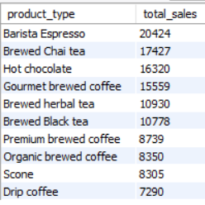

1. Total sales total_quanitiy and aorders with respect to may monday hour number 8

select

round(sum(unit_price *transaction_qty) , 1) as total_sales ,

sum(transaction_qty) as total_quantity ,

count(*) as total_orders

from coffe

where month(transaction_date) = 5 -- may

and dayofweek(transaction_date) = 2 -- monday

and hour(transaction_time) = 8;



1. total sales with respect to hours

select

hour(transaction_time) as Hour ,

round(sum(unit_price *transaction_qty) , 1) as total_sales ,

sum(transaction_qty) as total_quantity ,

count(*) as total_orders

from coffe

where

month(transaction_date) = 5 -- may

group by

Hour

order by

total_sales desc ;

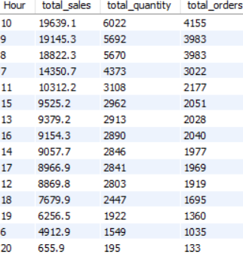

1. Total sales in each day in may

select

case

when dayofweek(transaction_date) = 2 then 'Monday'

when dayofweek(transaction_date) = 3 then 'Tuesday'

when dayofweek(transaction_date) = 4 then 'Wednesday'

when dayofweek(transaction_date) = 5 then 'Thursday'

when dayofweek(transaction_date) = 6 then 'Friday'

when dayofweek(transaction_date) = 7 then 'Saturday'

else 'Sunday'

end as Day_of_week ,

round(sum(unit_price *transaction_qty)) as total_sales

from

coffe

where

month(transaction_date) = 5

group by

Day_of_week

order by

total_sales desc ;

